Define problem statements.

Identifying the problems that users face is one of the most important parts of UX design. But as critical as research is to the UX design process, some of your work will still require a small amount of “mind reading” about the user’s experience. That might seem like it’s contradicting the rule of never making assumptions, but sometimes users just won’t feel comfortable or know how to express exactly what their problem is and how it affects them. In this reading, you’ll learn how to define unspoken pain points and use them to form strong problem statements.

**The connection between pain points and problem statements**

As a reminder, **pain points** are any UX issue or friction that frustrates the user and blocks them from getting what they need. Minimizing pain points keeps users happy and encourages them to keep interacting with the product. So, how do UX designers find and define pain points?

Think about the dog walker app and one of our user personas, Arnold. Arnold is in his late fifties, and his kids have encouraged him to upgrade to a smartphone. Arnold is a leader at his company, and not used to admitting he's uncomfortable with technology. After his wife died, Arnold became the primary caregiver of the family's animals. But, he works over sixty hours per week, and is unable to take his three dogs on twice-daily walks. Arnold is turning to the dog walker app for help.

Underneath graphic, text reads: Arnold Jones. Age: 58. Education: PhD. Hometown: Boston, Massachusetts. Family: Widowed, four adult kids. Occupation: Pharmaceutical executive.

You learned earlier that there are four categories pain points can fall into:

* **Financial**, or money-related pain points.
* **Product**, which are pain points related to quality issues.
* **Process**, which are pain points related to the user’s journey.
* **Support**, which are pain points related to getting help from customer service.

Identifying the pain points your user is experiencing will help you find potential problems that your design can solve. Arnold’s pain points fall into the process category. His biggest challenge is that he's not technologically savvy, so he struggles to understand how to use the app.

Now that you’ve identified Arnold’s pain points, you need to be sure you know enough about his needs to write a problem statement. **Problem statements** provide a clear description of the user’s need that should be addressed. To build a problem statement, you can utilize the 5 Ws framework.

**The 5 Ws and H: who, what, when, where, why, and how**

The most common framework used to create problem statements is the 5 Ws and H framework. After you define the user’s pain points, you can answer who, what, when, where, why, and how to solve the user’s problem.

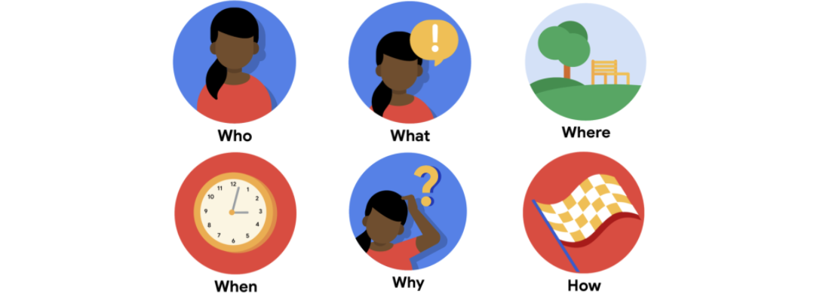

**Who** is experiencing the problem? Knowing your users and their background is key to creating successful solutions for them.

**What** are the pain points you’re trying to solve? Determining a user’s pain points early allows you to answer the rest of these questions and clarify the context of the pain points.

**Where** is the user when they’re using the product? A user’s physical context matters to your design.

**When** does the problem occur? Maybe it’s right after the end of a long and tedious process, or maybe it’s something that happens daily. Knowing when the problem occurs can help you better empathize with the user’s feelings.

**Why** is the problem important? Knowing how this problem affects your user’s experience and life will help to clarify the potential consequences.

**How** are users reaching their goals by using the product? Understanding how users reach their goals allows you to map the user journey that they take through your product.

To design a solution that fits the needs of your users, you have to understand the problem from their point of view. Thinking through the 5 Ws and how forces you to write out who the user is and describe the full context of the problem from the user’s perspective.

Okay, back to the dog walker app! You know a bit about Arnold already, but use the skills you’ve learned so far to confirm you know enough to solve his pain points.

* **Who:** A busy executive
* **What:** Arnold wants to hire a daily dog walker for his three dogs.
* **Where:** Arnold is likely using the app at work, on the go.
* **When:** Arnold gets frustrated when he opens the app, starting from the very beginning of the user journey.
* **Why:** Arnold doesn’t have a lot of experience with phone apps or similar technology.
* **How:** Arnold wants to go easily from the home screen of the app to the list of dog walkers to the confirmation screen.

Ta-da! You were able to successfully answer all six questions. Now that you’ve thought through your user’s needs, you’re ready to define the final problem statement.

**The problem statement formula**

So, how do you create a problem statement? Start by defining who the user is and what their needs and motivations are. Here’s the formula we introduced in the video:

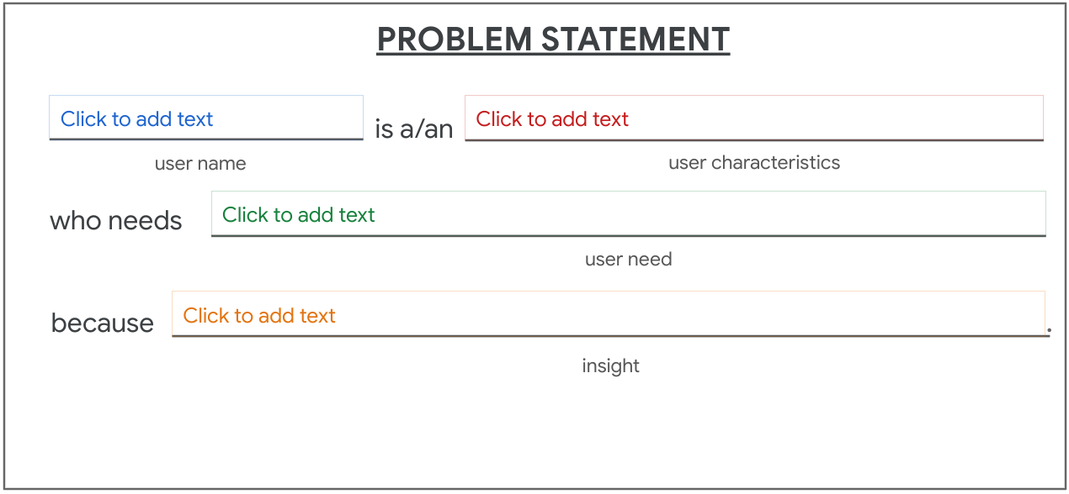[user name] is a/an [user characteristics] who needs [user need] because [insight]

Okay, now apply the formula to Arnold. Arnold is a busy professional who needs a dog walker. But what’s the insight? His phone! His kids gave him a shiny, new smartphone. Arnold shared that he often struggles with technology and is having an issue navigating the app.

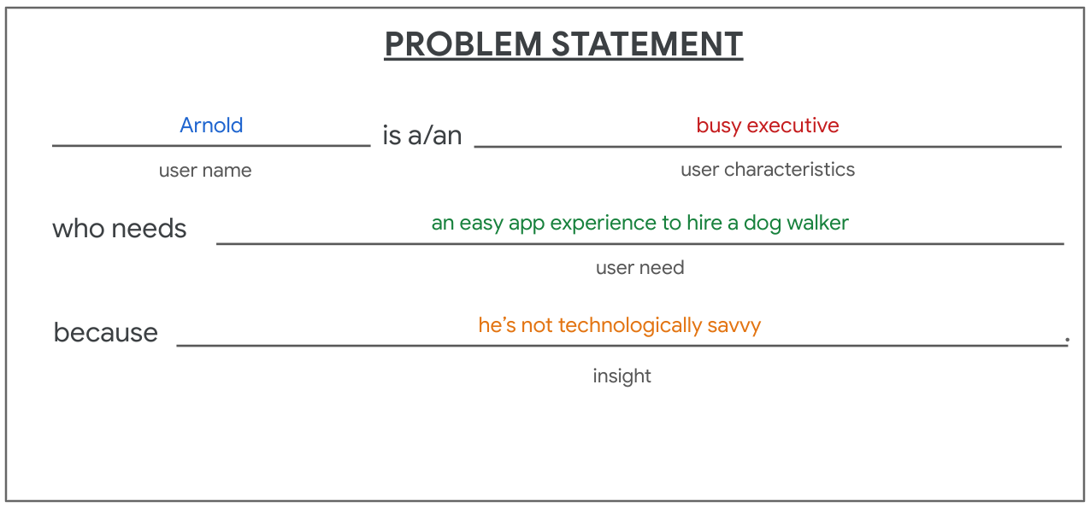Arnold is a/an busy excutive who needs an easy app experience to hire a dog walker because he's not technologically savvy.

Arnold is a busy executive who needs an easy app experience to hire a dog walker because he's not technologically savvy.

**The impact of problem statements**

Problem statements provide clarity about your users’ goals and help UX designers identify constraints that prevent users from meeting those goals. Problem statements also help your team measure success. If you expect that Arnold and users like him will engage the most with your app, you should make the app clear and easy for them to understand.

The designs you create matter! Empathize with your user as much as you can to make a product that they’ll want to interact with and use every day.

# Learn more about defining user problems

You’ve already learned why it’s important to make sure you’ve defined the right user problem before designing solutions. So, are you ready to boost your reading list? These resources will help you develop a deeper understanding of the **define** stage of the design process.

* [Design Problem Statements: What They Are and How to Frame Them](https://www.toptal.com/designers/product-design/design-problem-statement) from Toptal
* [User Need Statements: The 'Define' Stage in Design Thinking](https://www.nngroup.com/articles/user-need-statements/) from Nielsen Norman Group
* [Are you solving the right problem?](https://hbr.org/2012/09/are-you-solving-the-right-problem) from Harvard Business Review